Proposal Request Form for ISO Management System Certification | 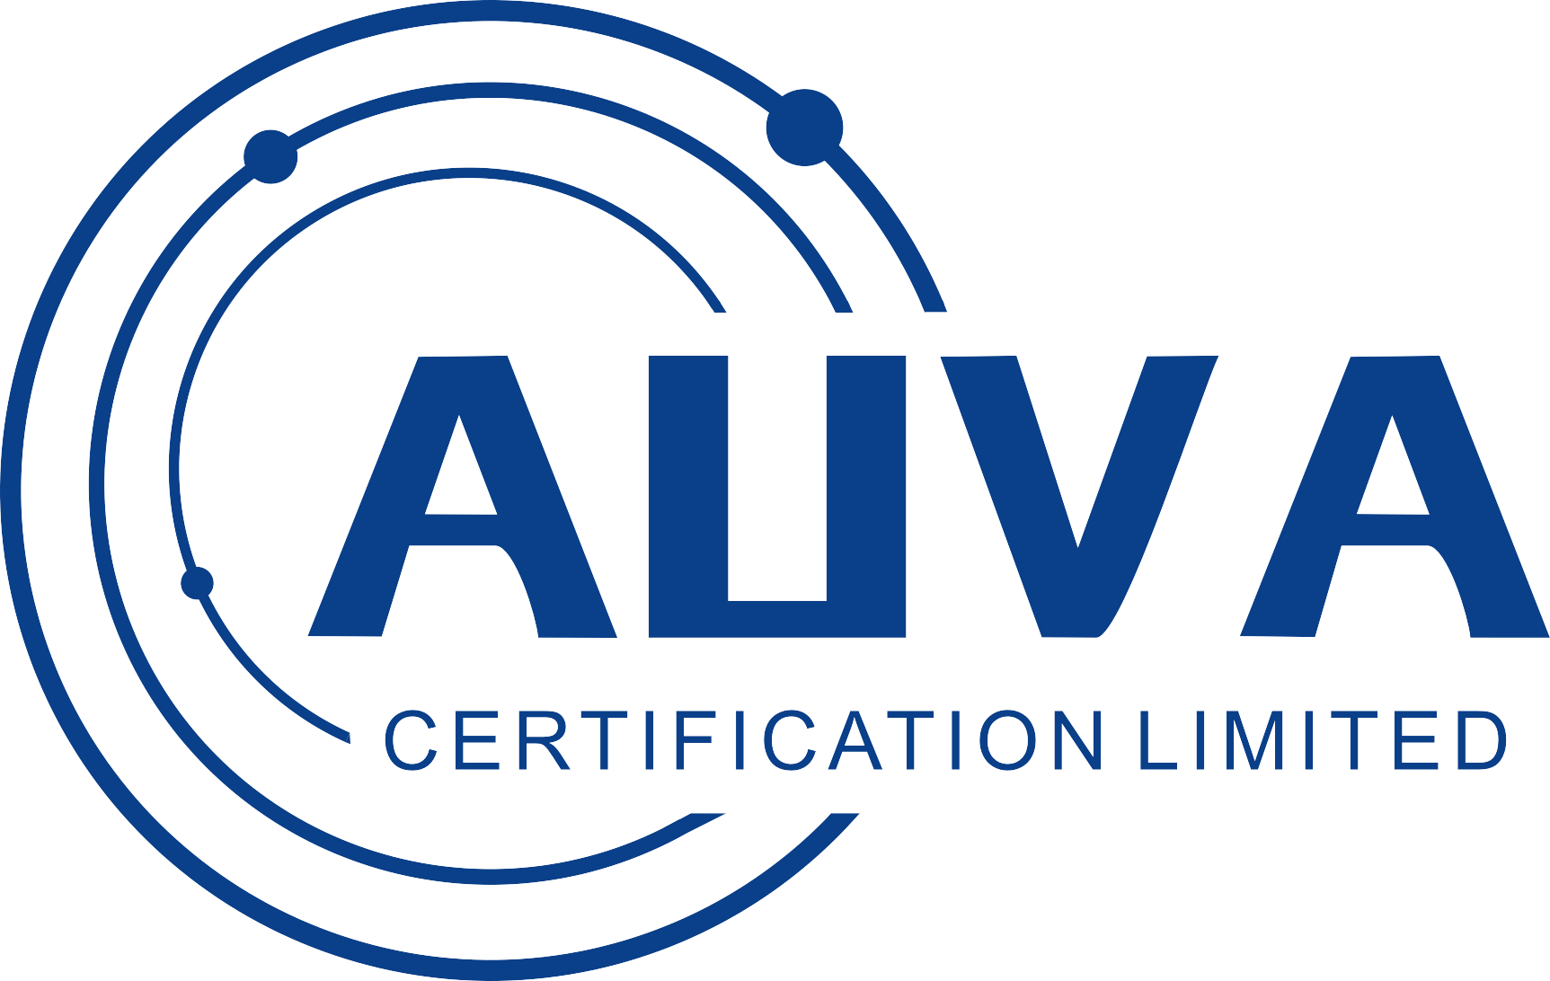
- The completed application form will allow us to provide an ISO certification proposal;
- If you are unsure about any of the questions contact UK AUVA on 028 71 337700;
- Information provided in this form will be kept confidential;
- This form can be completed electronically and emailed to info@UK AUVA.org.
1. Company Details
Name of Your Company:
Main Office Address:
Postcode:
Telephone
Number:
Contact  Name: |  | Contact  Job Title:
Email  Address: |  | Date:

2. Tick or place an “X” indicating which Standard you are seeking certification for and if new or if transferring certification from another certification body:
 | ISO 9001:2015 Quality Management Standard |  | New Management System |  | Transfer of certificate from other certification body
 | ISO 14001:2015 Environmental Management Standard |  | New Management System |  | Transfer of certificate from other certification body
 | ISO 45001: 2018 Occupational Health and Safety Standard |  | New Management System |  | Transfer of certificate from other certification body
Safety Schemes in Procurement (SSIP)
 | SSIP  Contractor |  | SSIP Principle Contractor |  | SSIP Designer |  | SSIP Principle Designer

3. Details of Head office, additional locations and staff numbers
Location | Location Address (if different from above address) | Number of shifts | Number of staff in Management | Number of staff in Administration | Number of staff in production/  service | Total number of staff
Head office
Additional Sites
List the positions or roles held by staff in your company, at offices, production, operations, or temporary work sites.

4. How many temporary work sites on average does the company have. Temporary sites are typically construction or sites where maintenance or installation work is carried out.

5. Out Sourcing/Sub-contractors. Does your Company outsource/sub-contract any activities?
If yes describe what the sub contracted or outsourced staff do:

How many subcontracted or outsourced staff work for your Company?

Do Subcontracted or outsourced staff work as if they are full time staff, part-time, or on occasions when specialised work is required eg electrical installation.

6. Certification Scope. What company activities are to be covered by the certification ie the scope of certification? Describe the products and/or services provided by your company:

7. Processes/operations. Describe the processes/operations completed by your company:

8. List Key Health and Safety Hazards and Risks associated with Company Processes
Main hazardous materials used by the company:

9. Legal. Any legal obligations regarding Health and Safety laws. Note any legal licences, consents or permits held by your Company?
Eg Occupational health and safety laws

10. Information about the Management System
When would you wish to gain ISO certification by:

If you are using a consultant to create your ISO management system can you provide:
Consultant name:
Consultancy name:

Is Your Company certified to any other standards? If yes can you provide details of other certification/s in the box below:

Where did you hear about UK AUVA?

Once we receive your completed Request for Certification Proposal Form we will create a proposal and send a copy along with supporting information.
Our contact details: Email: info@UK AUVA.org Tel: 0044 2084 323 088 Address: UNIT G25 WATERFRONT STUDIOS 1 DOCK ROAD LONDON UNITED KINGDOM E16 1AH Re-Issued: 11th February 2020, Issue: 7

